«First_Name» «Last_Name» September 1 2015
«Company»
«City»

Dear «First_Name»,

Re: Our 28th Annual Gala of Hope – Delta Hotel, November 4, 2015
This summer Camp Circle O’Friends (CCOF) celebrated its 29th year of operation, thanks to the support of our club and sponsors like you. Ninety children, plus 50 camp counselors and medical staff, attended the camp at Last Mountain Lake this past June.
The Canadian Progress Club - Regina Centre is a non-profit volunteer membership organization. Our fund raising activities benefit Camp Circle O' Friends, as well as other charitable organizations. Through the generosity of corporate sponsors, local businesses and long-time supporters we were able to contribute over $1,000,000 to Camp Circle O’ Friends over the past 27 years. This money, together with money raised from other organizations, is used to pay operating expenses for the camp and to purchase special needs equipment such as bunk beds and mattresses or supplies for the medical first-aid rooms.
You can help in a number of ways:
- Donate an item for our live or silent auction or for the raffle
- Purchase a ticket or a corporate table for 8 or 10 persons
- Buy an ad in our program
- Host or sponsor the reception or a portion of the dinner
Your support of this evening for Camp Circle O’ Friends will help ensure the viability of the camp for next year and will help other charitable organizations in our community. I will contact you by phone in the near future to provide further information.
Your contribution will be recognized in the Gala of Hope dinner program and special signage at the event. It will be greatly appreciated, especially by the children fighting cancer who look forward to attending Camp Circle O' Friends each year. Thank you for considering a donation and I look forward to speaking with you personally in the near future.

Sincerely,
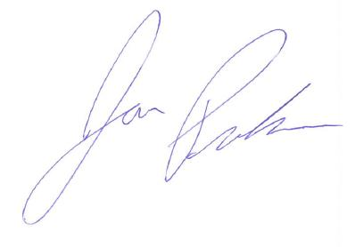
Jon Promhouse
Phone: (306) 721-1710

